OE3C 2024 Summary Statistics

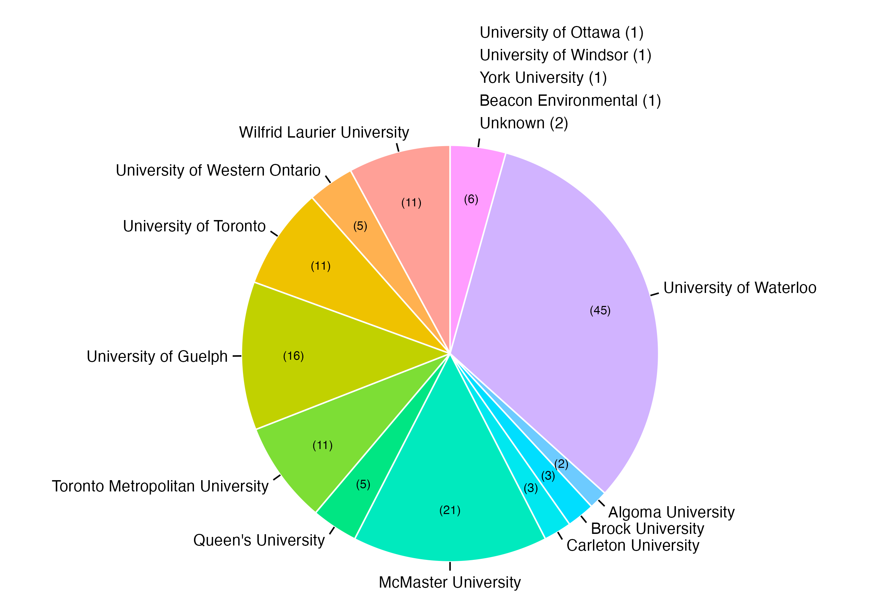

A

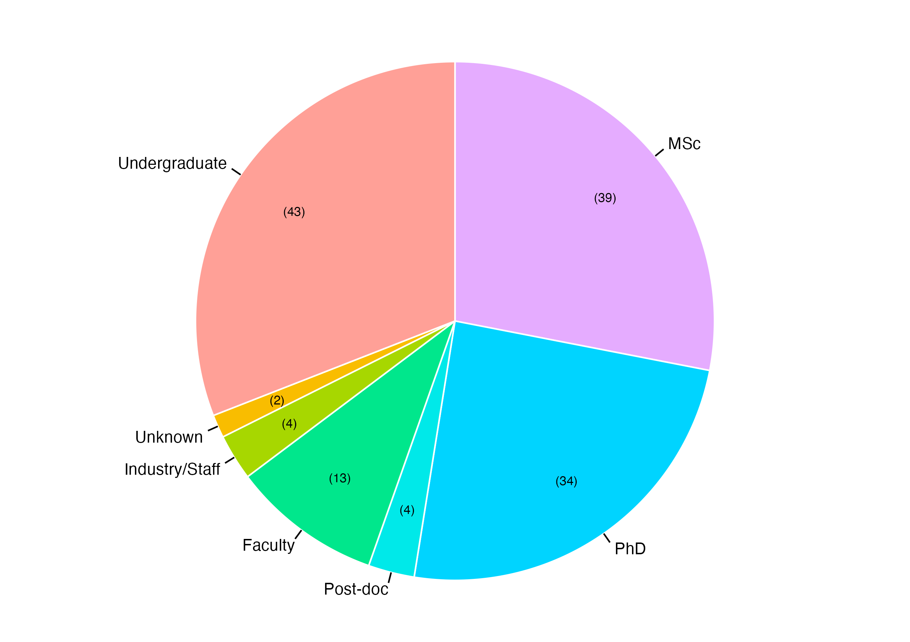

B

Figure 1. OE3C 2024 hosted a total of 139 attendees. A) Number of attendees by affiliation shown in brackets and B) number of attendees by academic stage shown in brackets.

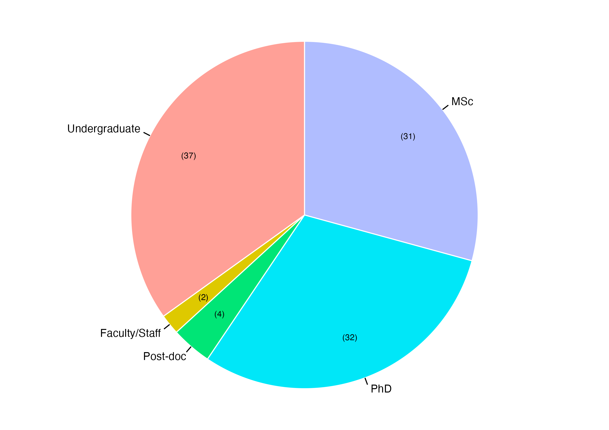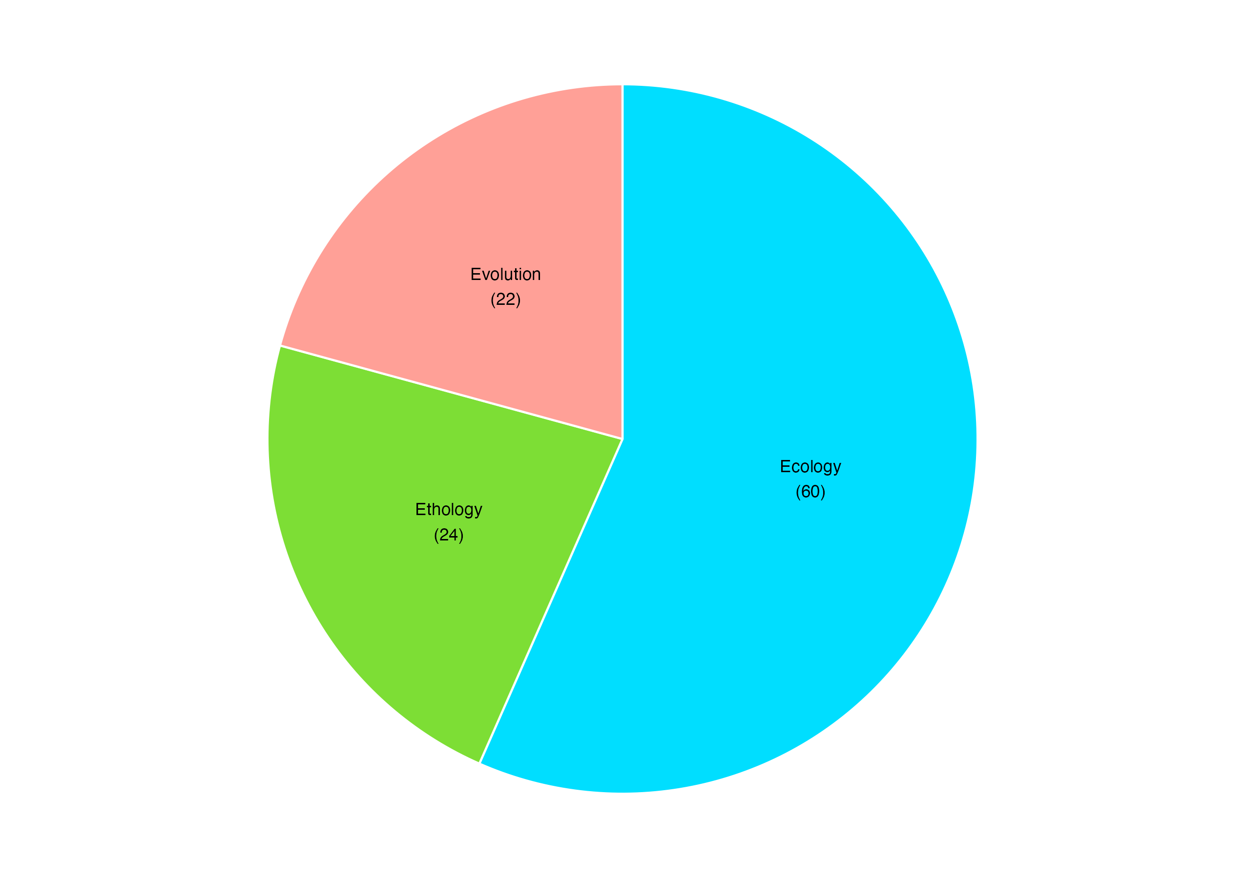

A

B

Figure 2. OE3C 2024 featured 106 presentations. A) Number of presentations by academic stage of presenter shown in brackets and B) number of presentations by primary discipline shown in brackets.

Table 2. A total of 88 student presentations entered the competition. Presentations were categorized by academic stage of presenter and presentation type. Number of competing presenters in each category, award winners, and disciplines of winning presentations are also shown.

|  |  |  |  |  |  |
| --- | --- | --- | --- | --- | --- |
| Competition Category | Number of Presenters | Award Winners | Ecology | Ethology | Evolution |
| Undergraduate Poster | 20 | Best: Ana Veneat | Badge Tick1 outline | Badge Tick1 outline | Badge Tick1 outline |
| Runner-up: Ningrui Xie | Badge Tick1 outline |  |  |
| Undergraduate Talk | 12 | Best: Reyad Malakh | Badge Tick1 outline | Badge Tick1 outline | Badge Tick1 outline |
| Graduate Poster | 15 | Best: Shane Seheult | Badge Tick1 outline |  |  |
| MSc Talk | 19 | Best: Susheen Mahmood |  | Badge Tick1 outline | Badge Tick1 outline |
| Runner-up: Ainsley Harrison-Weiss | Badge Tick1 outline | Badge Tick1 outline |  |
| PhD Talk | 22 | Best: Brendan McEwen | Badge Tick1 outline | Badge Tick1 outline | Badge Tick1 outline |
| Runner-up: Kelly McLean | Badge Tick1 outline | Badge Tick1 outline |  |

**OE3C 2024 Free Attendees:**

* 9 free UWaterloo undergrads + 2 undergrad committee (Mathumy, Harry)
* 19 free UWaterloo graduate students + 4 graduate committee (Beatriz, Lily, Michela, Ryan)